LIGHTNING PROTECTION SYSTEM

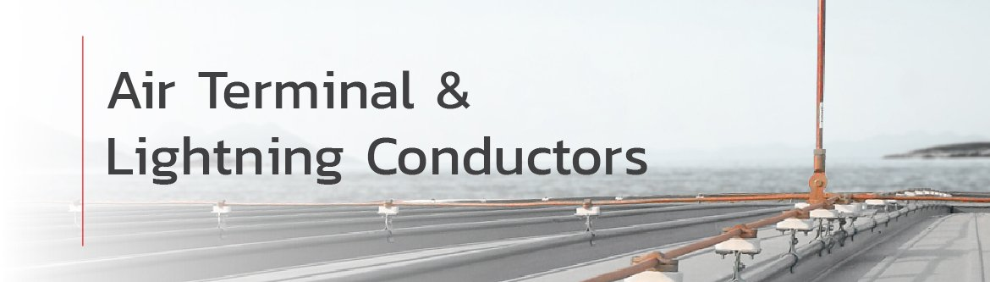

Air Terminals are the primary interception components of a lightning protection system and play a critical role in safely capturing and directing lightning currents to ground. Proper design and product selection in accordance with international standards are essential to ensure effective system performance and protection.

KUMWELL’s range of Lightning Air Terminals [blunt-end rods, multi-point air terminals, lightning conductors, Franklin rod systems] are manufactured and tested in compliance with IEC 62561-2, and form part of a conventional passive lightning protection system compliant with the rolling sphere, mesh (Faraday cage), and protective angle methods described in IEC 62305.

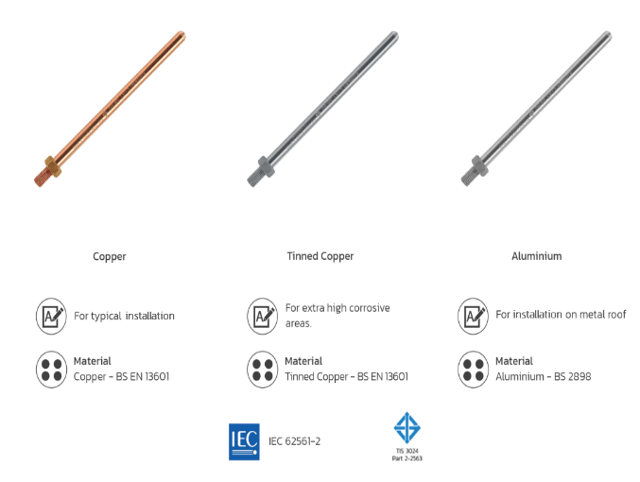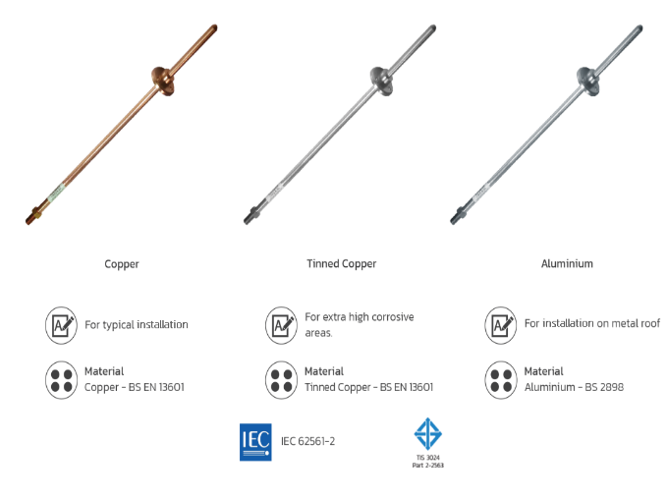

Lightning Conductors
Tape Conductors
Tape conductors are easy to install, with no need to straighten for a neat finish. Available in copper or aluminium, tape conductor can be installed bare or with a choice of PVC covering to enable the tape to blend with modern building fabrics
Circular Conductors
Circular conductors can be used in applications where aesthetic considerations are important. Circular conductor is less conspicuous than the tape conductor system and lends itself much better to being concealed. Available in copper or aluminium, circular conductors can also have PVC covering.
Bare Copper
Made from BS EN 13601 copper, bare copper passes IEC 62561-2 standard. It is suited for grounding systems and lightning protection systems.
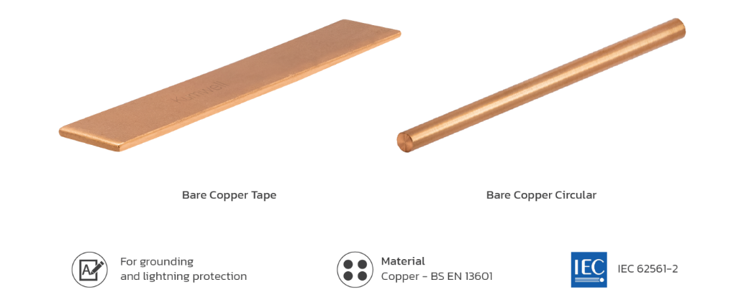
Copper with PVC
Made from BS EN 13601 with high conductivity copper and green PVC cover with low smoke halogen free (LSHF), Also copper with PVC passes IEC 62561-2 standard. It is suited for down conductor in lightning protection.
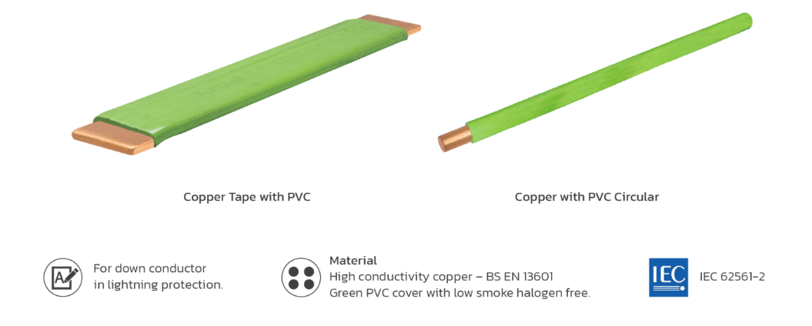
Annealed Copper-Clad Steel Wire (CCS)
Made from a cladding between steel and copper, CCS is a grounding grid according to IEC 62305-3 and IEEE 80-2013 standards. It also passes ASTM B910-B910M and IEC 62561-2 standard tests. It is suited for grounding systems and solutions for thefts prevention.
